Adaptacja strategii biogospodarki w przedsiębiorstwach w wybranych krajach UE (1)
https://www.youtube.com/watch?v=byYY8BEFZrs

https://www.youtube.com/watch?v=byYY8BEFZrs

https://www.youtube.com/watch?v=ZvGvxtXPsrI

Gospodarka o obiegu zamkniętym jako narzędzie promocji nowych i biomateriałów w dziedzinie opakowań – wyzwania polityczne w różnych regionach

https://www.youtube.com/watch?v=TqXXUgV6TY4

https://www.youtube.com/watch?v=TovnyxNKWeA

Charakterystyka polimerów jako surowców stosowanych do produkcji materiałów opakowaniowych, w tym „nowych” i „bio” oraz metod produkcji
https://www.youtube.com/watch?v=mWRlQ5ZJEsw

Materiały do produkcji opakowań żywności – wymogi prawne, właściwości oraz ich wpływ na materiały

https://www.youtube.com/watch?v=DMDiKoAAZbI
https://www.youtube.com/watch?v=3rkn198eYmw

Analiza i ocena materiałów opakowaniowych stosowanych do produkcji opakowań z uwzględnieniem kontaktu z żywnością

https://www.youtube.com/watch?v=gwJ6q2IHV6M

PROJECT INFO
Grant Agreement | 612212-EPP-1-2019-1-ES-EPPKA2-KA
Programme | Erasmus+
Key Action | Cooperation for innovation and the exchange of good practices
Action Type | Knowledge Alliances for higher education
Project Title | PackAlliance: European alliance for innovation training & collaboration towards future packaging
Project starting date | 01/01/2020
Project end date | 31/12/2022
Project duration | 3 years
This project has received funding from the European Union

PROJECT CONSORTIUM
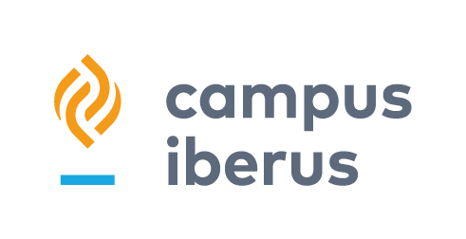 |  |  | 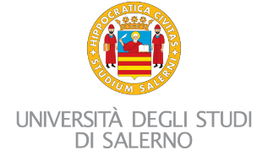
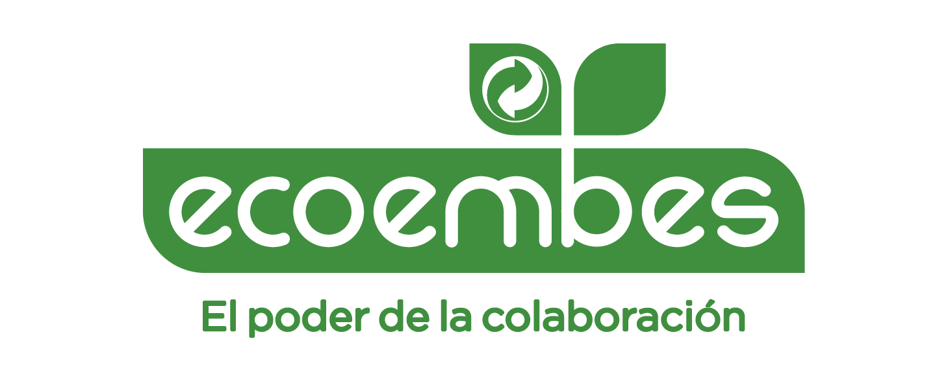 |  | 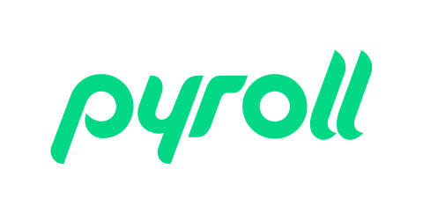 | 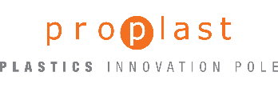

Copyright: CC BY-NC-SA 4.0: https://creativecommons.org/licenses/by-nc-sa/4.0/
With this license, you are free to share the copy and redistribute the material in any medium or format. You can also adapt remix, transform and build upon the material.

However only under the following terms:
Attribution — you must give appropriate credit, provide a link to the license, and indicate if changes were made. You may do so in any reasonable manner, but not in any way that suggests the licensor endorses you or your use.
NonCommercial — you may not use the material for commercial purposes.
ShareAlike — if you remix, transform, or build upon the material, you must distribute your contributions under the same license as the original.

No additional restrictions — you may not apply legal terms or technological measures that legally restrict others from doing anything the license permits.

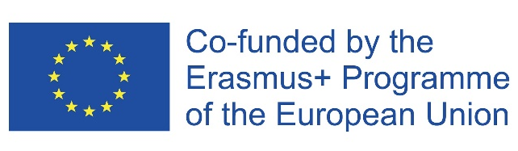
The information and views set out in this report are those of the authors and do not necessarily reflect the official opinion of the European Union. Neither the European Union institutions and bodies nor any person action on their behalf may be held responsible for the use, which may be made of the information contained therein.

